Experiment Number: 6

Problem Statement: Design an Assignment to retrieve, verify, and store user credentials using Firebase Authentication, the Google App Engine standard environment, and Google Cloud Data store

NAME:Bhagyesh Sujitkumar Gaikwad ROLLNO: 81
CLASS: IT-B BATCH: B3
DATE OF PERFORMANCE: 04-04-2025

Steps:

- Go to Firebase Console
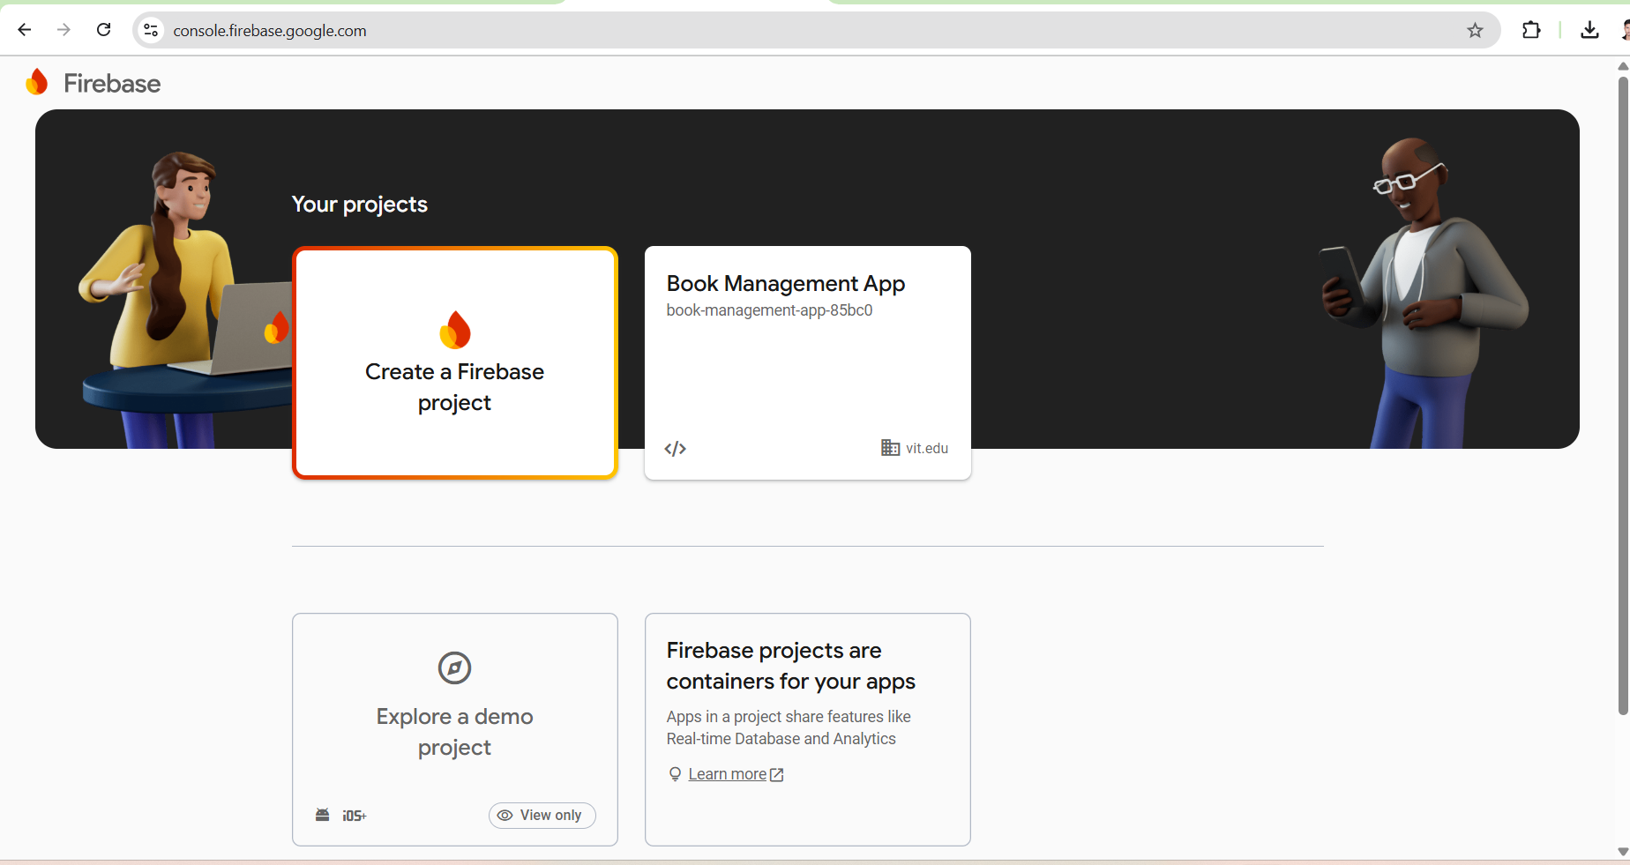

- Create a Project or select a existing project
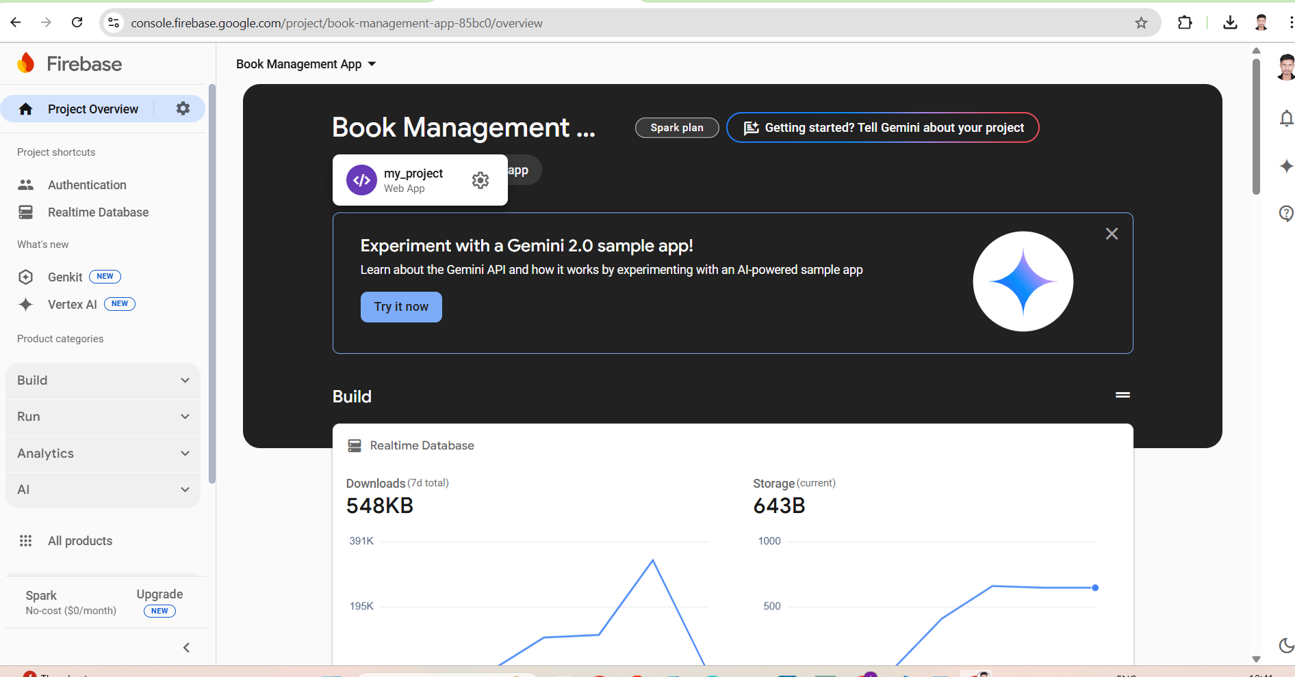

- Enabling Firebase Authentication and its providers
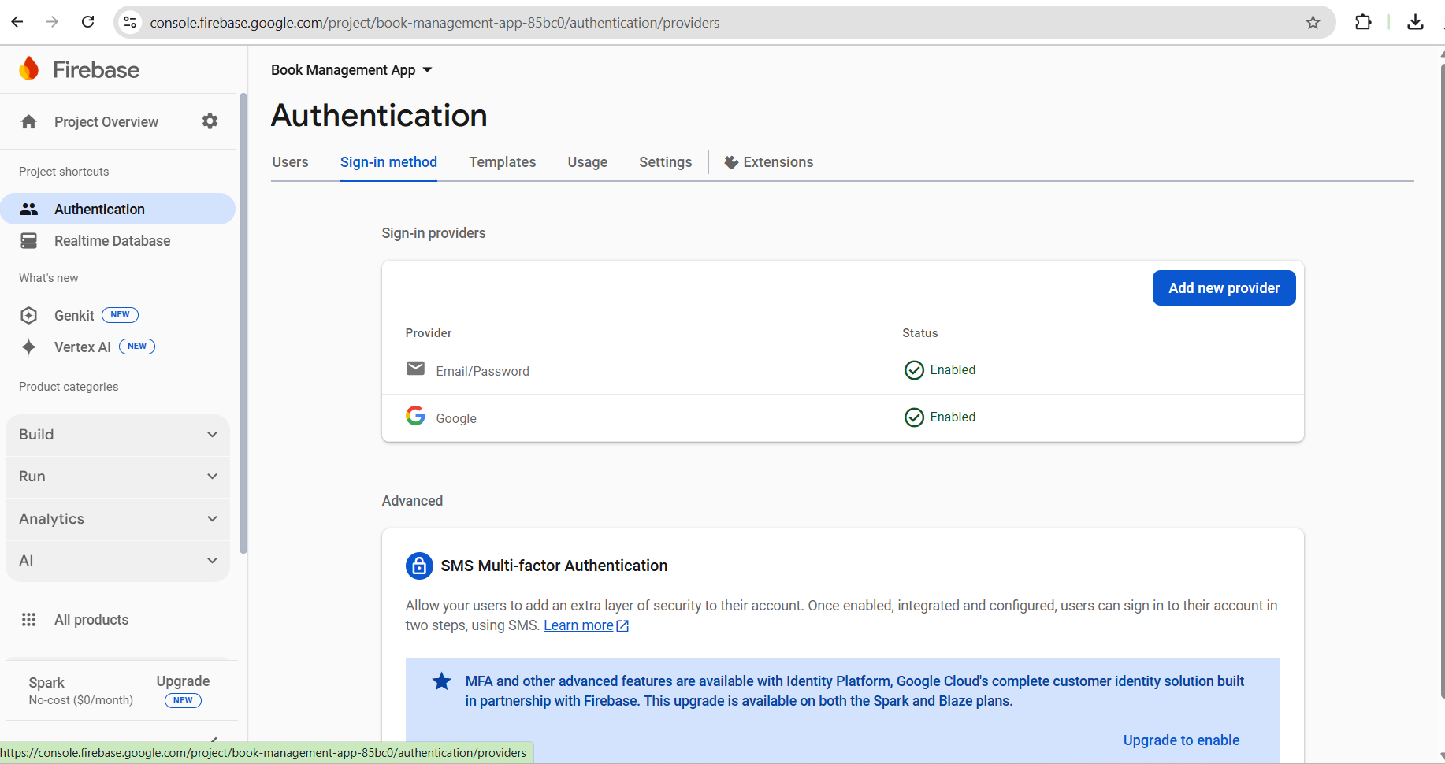

- Defining Firebase Realtime Database Rules

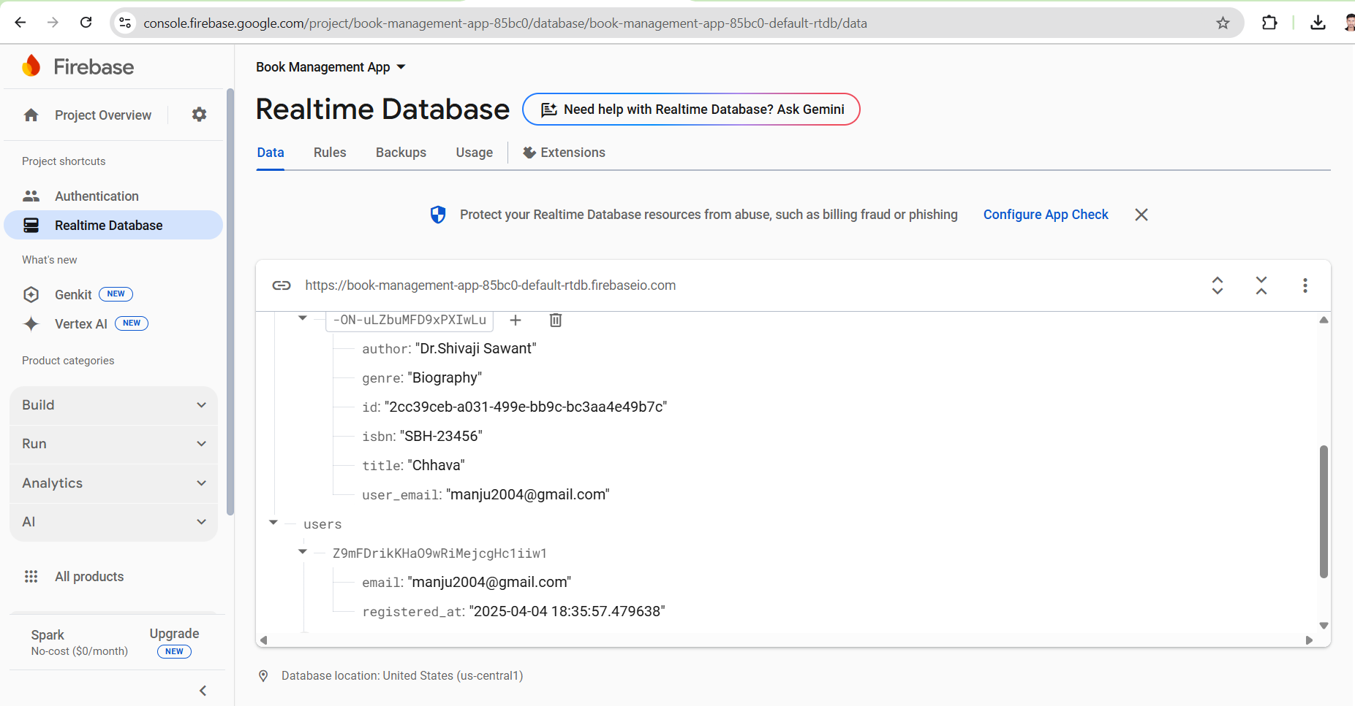

- Firebase-config.js
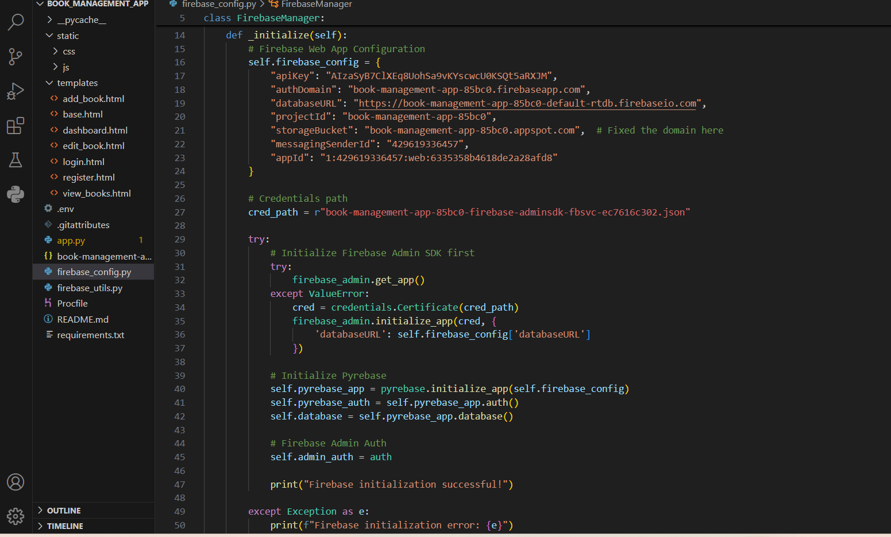

- Firebase-Auth for Login
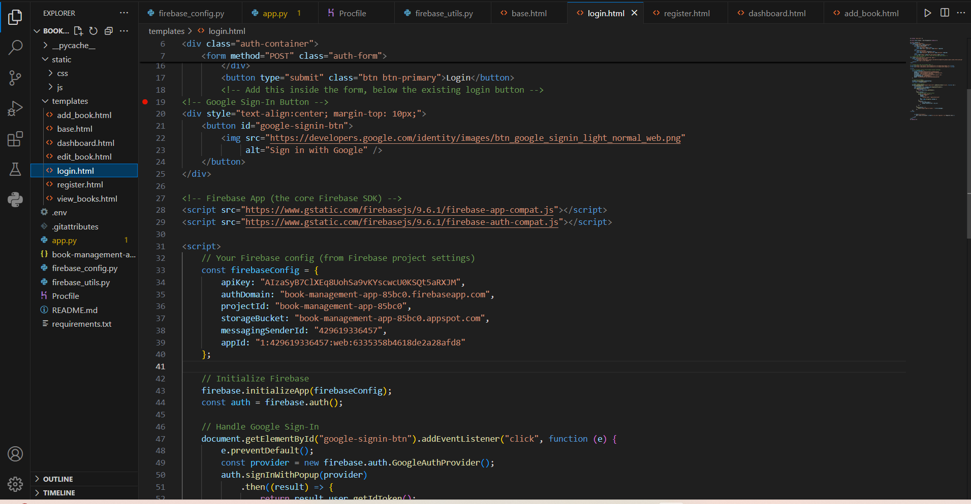

Firebase-Auth for register and sign in with Google

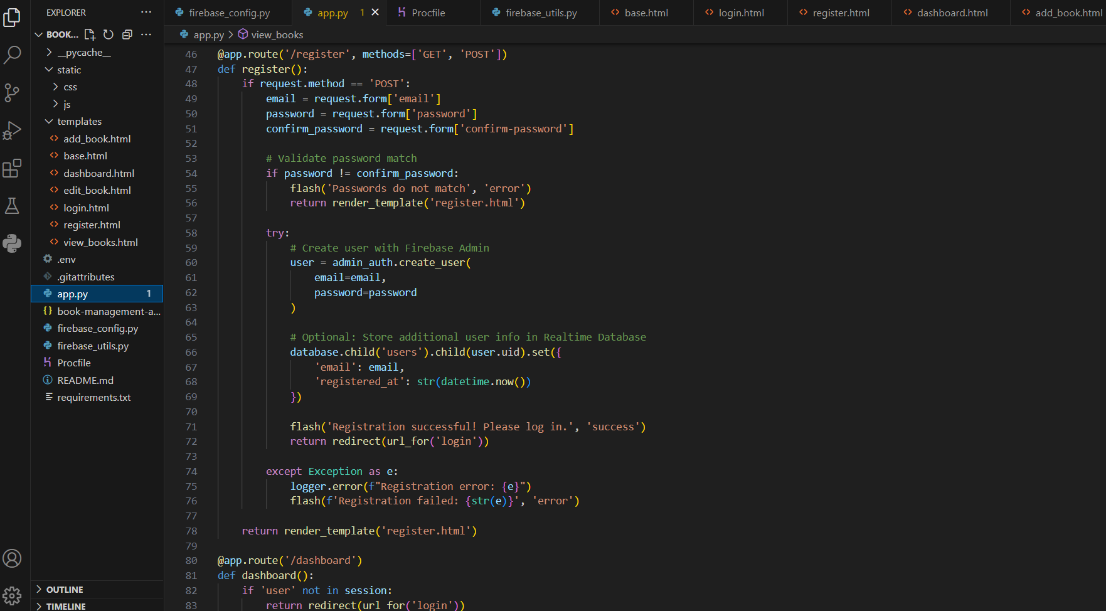

Store user results in Firebase Real time Database

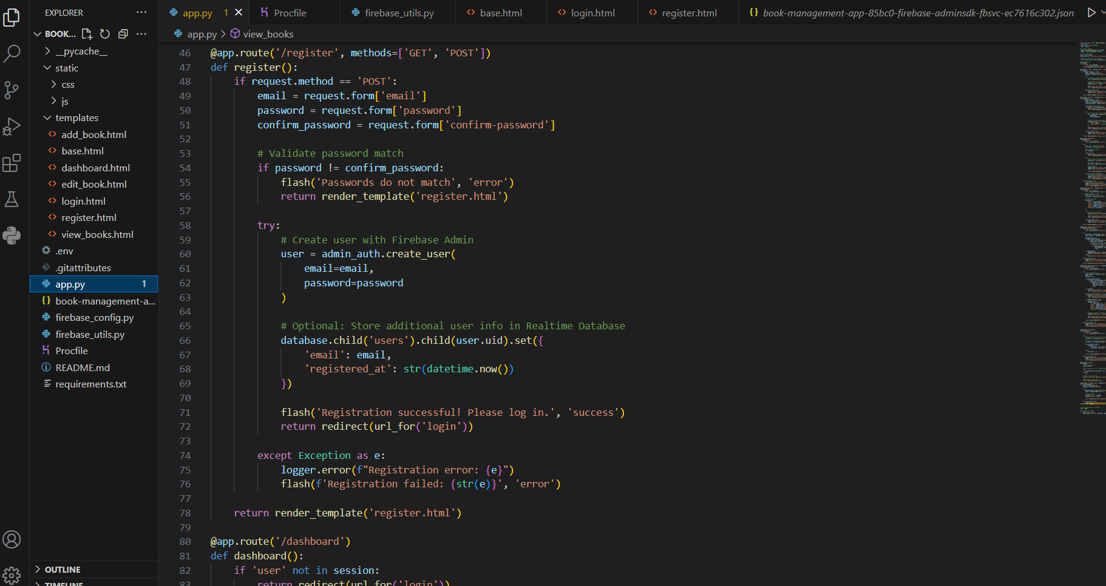

Registered Users

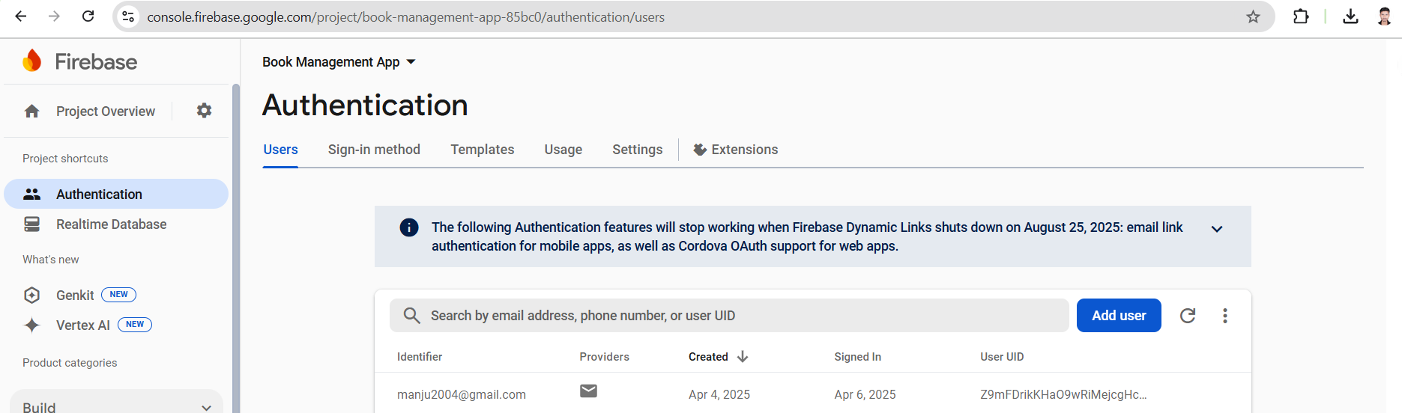

User’s Data in Firebase Real time Database



Conclusion:
In this task, we successfully retrive, verify, and store user credentials using Firebase
Authentication and Store Data using the Firebasebase Realtime Database .
By following the streamlined steps, we efficiently add the authentication to the developed
application, demonstrating the ease of using Firebase Auth and Real time Database for
continuous and realtime usage ,track and store data , leveraging web.app for efficiency and
security for rapid deployment.

